**CARIBBEAN ADVANCED PROFICIENCY EXAMINATION**

**(C.A.P.E)**

**CARIBBEAN STUDIES**

*Title: The Effects of Waterborne and Vector-borne diseases in Society*

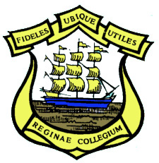

**Name of Candidate: Sonny Kothapally**

**Candidate Number: 090041 _ _ _ _**

**School: Queen’s College**

**Centre Number: 090041**

**Territory: Guyana**

**Teacher’s Name: Mr. Roger Small**

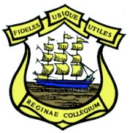



Queen’s College,

Camp and Thomas Road,

Georgetown.

24th December, 2014.

Dear Respondent,

Thank you for taking part in this questionnaire survey related to diseases in Stabroek, Georgetown. I am Sonny Kothapally, a second year CAPE Caribbean Studies student from Queen’s College, Guyana. Today, I will be gaining your thoughts and opinions on diseases to understand the impacts of disease in the future. This questionnaire should only take 4-5 minutes to complete. Be assured that all responses you provide will kept confidential. Please turn over the page to proceed.

Yours faithfully,

Sonny Kothapally

Student